 | θ | d | A | α
$$0-1$$ | q1 | L0 | 0 | π/2
$$1-2$$ | q2 | 0 | L1 | 0
$$2-3$$ | q3 | 0 | L2 | 0
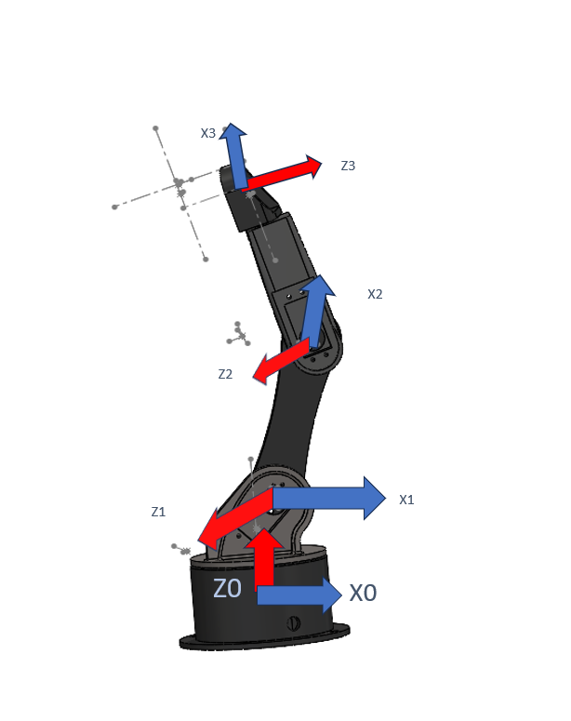
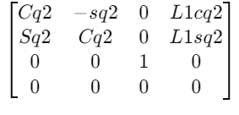
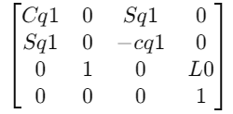
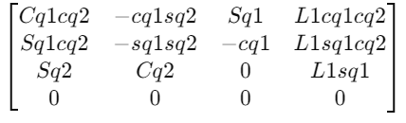

2T0=

1T0=

2T1=

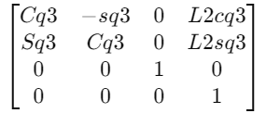

3T2=
X1
₃T⁰ =
$$\begin{matrix}Cq1Cq2Cq3-Cq3sq1sq3 & -cq1cq2cq3-cq1Sq2Sq3 & \begin{matrix}sq1 & Cq1Cq2L2Cq3-cq1Sq2l2sq3+l1Cq1Cq2\end{matrix} \\ \begin{matrix}Sq1Cq2Cq3+Sq1Sq2Cq3 \\ S\left(q2\right)C\left(q3\right)+C\left(q2\right)S(q3)\end{matrix} & \begin{matrix}-S\left(q1\right)C\left(q2\right)S\left(q3\right)-S\left(q1\right)S\left(q2\right)C(q3) \\ -S\left(q2\right)S\left(q3\right)+C\left(q2\right)C(q3)\end{matrix} & \begin{matrix}\begin{matrix}-Cq1 \\ 0\end{matrix} & \begin{matrix}Sq1Cq2l2Cq3-Sq1Sq2L2Sq3+l1s\left(q1\right)Cq2 \\ sq2l1cq1cq2+cq3l1sq1Cq2+l1s(q2)\end{matrix}\end{matrix} \\ 0 & 0 & \begin{matrix}0 & 0\end{matrix}\end{matrix}$$
The Above where the DH convention paprameters and the Table :
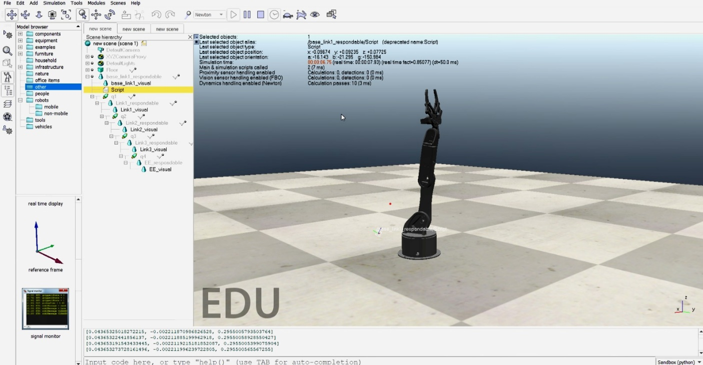
This Image in Copiliasim

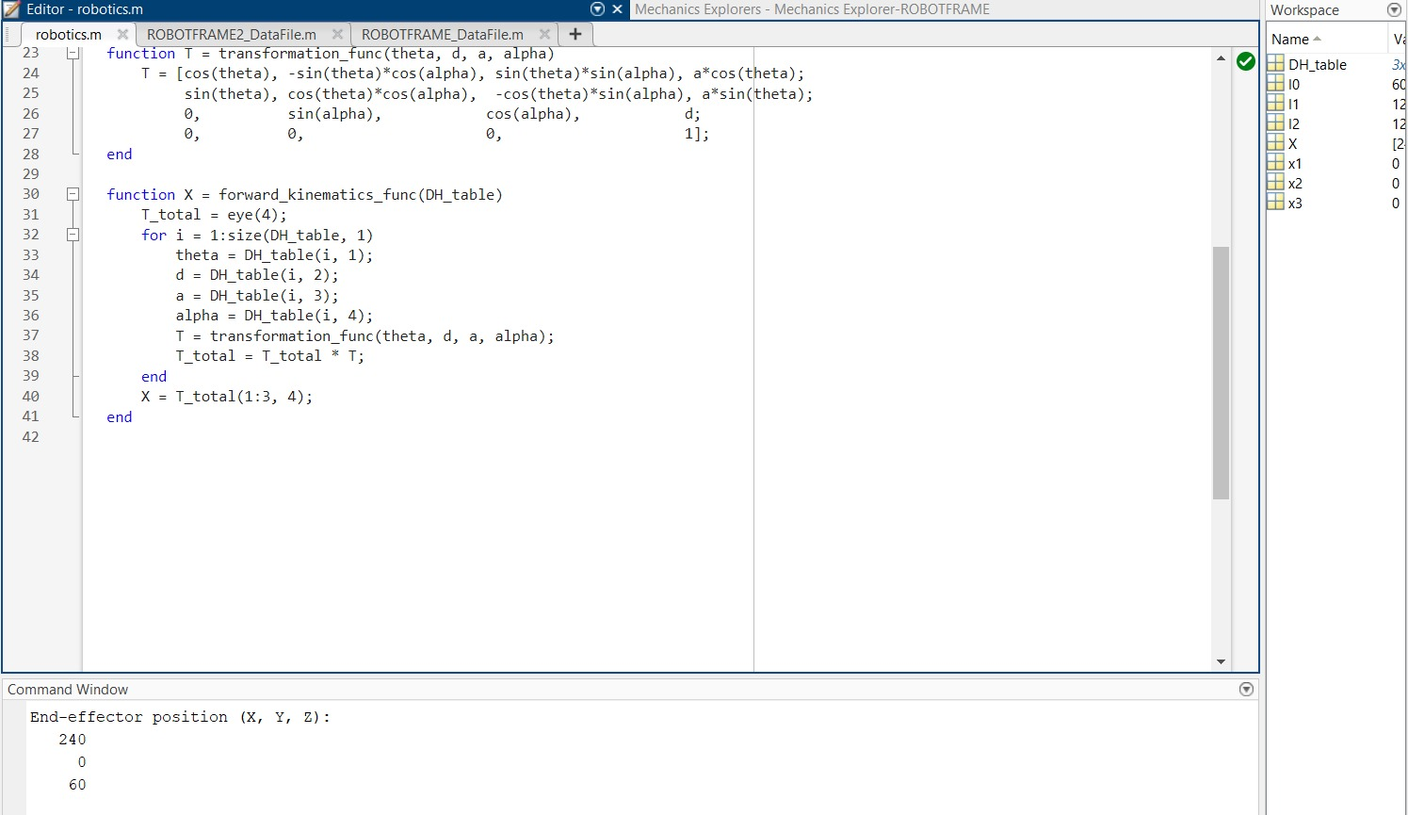

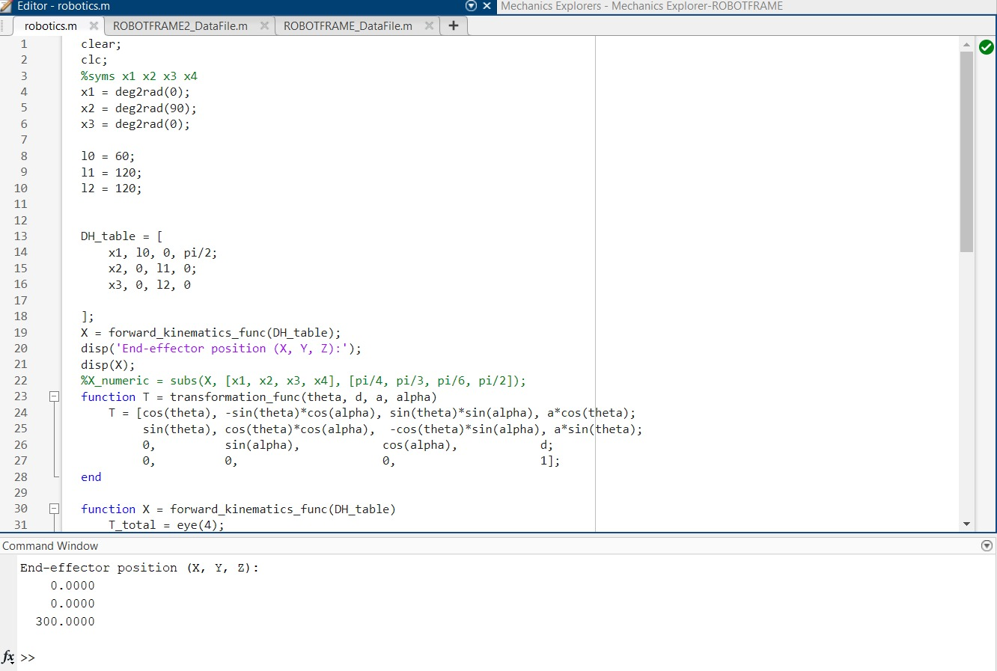

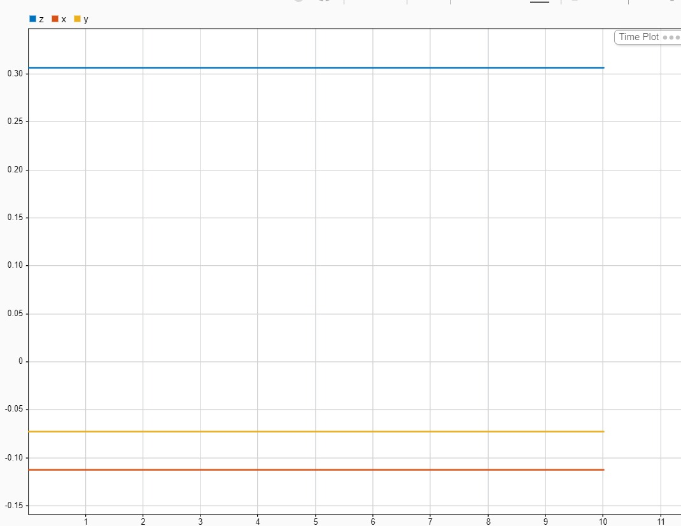
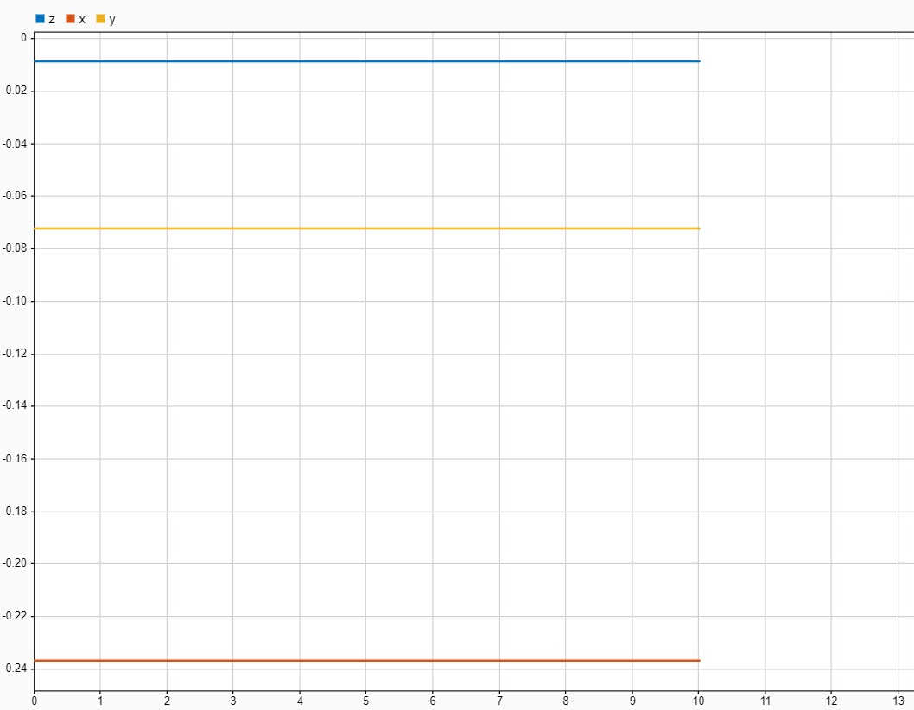
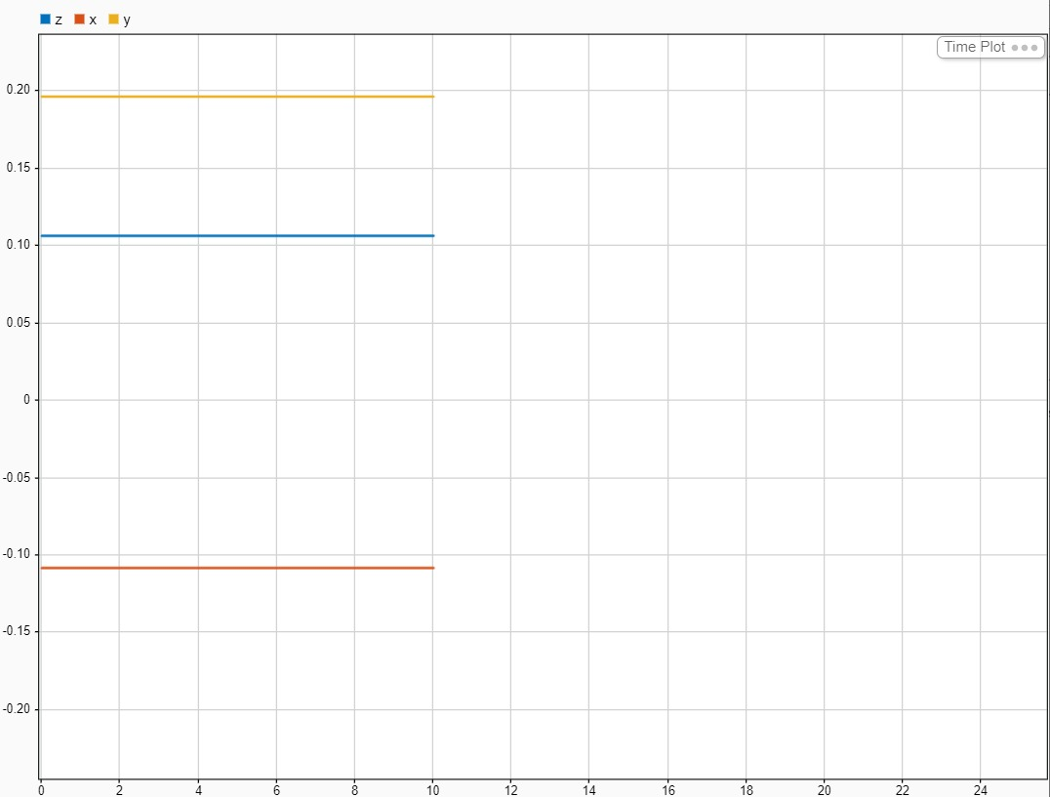
The Above images are from Matlab These are not as accurate as possible as we ddidnt take into the concederation the thickness of links but the x and y and z are perfect the problem is the thickness
The above are the Simulink results : Image 2:
- Graph Content: The plot displays three different variables labeled as z, x, and y. Each variable is represented by a colored line:
  - z (blue): The value remains constant at approximately 0.30 across the x-axis.
  - x (yellow): Constant around -0.10.
  - y (orange): Constant around -0.15.
- Analysis:
  - The graph shows that these variables have stable values over time, with no significant fluctuation.
  - The difference in magnitude between z, x, and y suggests they might represent system parameters like forces, positions, or velocities, depending on the system you're simulating.
  - This stability implies that the system has reached a steady state, or the dynamics of these specific components are not changing with time.
Image 3:
- Graph Content: Similarly, this plot shows variables z, x, and y over time:
  - z (blue): Constant around 0.10.
  - x (yellow): Constant around 0.20.
  - y (orange): Constant around -0.10.
- Analysis:
  - Again, all three variables are steady with no changes over time. The values are at different levels, which suggests they could be representing distinct physical properties or system components.
  - The fact that all lines are flat indicates that the system is in equilibrium, with no dynamic behavior happening over the observed time frame.
General Conclusion:
- Both graphs indicate that the system being simulated is in a steady state for the variables z, x, and y. There are no oscillations or trends over time.
- To make a deeper analysis, it would help to know what these variables represent (e.g., voltage, current, force, displacement) and the specific system being modeled. However, from the visual evidence, it looks like the system has reached equilibrium.
If you can provide additional context (such as the nature of the system being simulated), a more specific interpretation can be provided
Lastely we printed and puted the motors on the arm as shoen in the below images